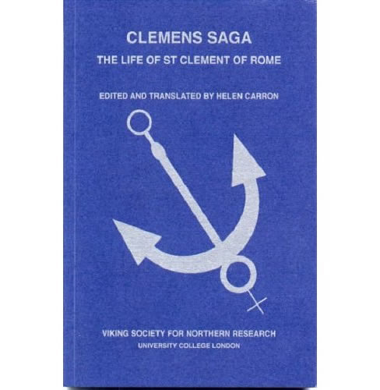
Clemens saga belongs to the genre of heilagra manna sögur (saints’ lives), many of which were among the first vernacular texts to be written in Iceland. It is a Life of St Clement of Rome (died c.100), supposed to have been the third successor of St Peter as Pope. The first part is derived from the Clementine Recognitions, purportedly Clement’s autobiography, which is a romance telling of the separation and eventual reconciliation after many adventures of members of Clement’s family. The second part tells how they were all converted to Christianity by St Peter, and Clement himself finally became Pope and was martyred by the heathen Romans by having an anchor tied round his neck and being thrown into the sea, and various miracles performed as a result of his saintliness.
This edition by Helen Carron presents the Icelandic text, with facing English translation and introduction.

