Hrafnagaldur Óðins

Hrafnagaldur Óðins (Forspjallsljóð).
Edited with introduction, notes and translation by Annette Lassen.
Viking Society for Northern Research 2011. Paperback. ISBN 9780903521819. Price £10 (£5 to members of the Viking Society).
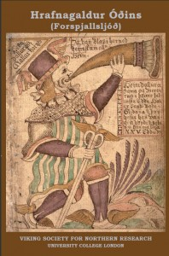
This anonymous poem in eddic style is shown in this edition to have probably originated in Skálholt in the mid seventeenth century. The main title probably meant ‘Song of Óðinn’s ravens’, i.e. one of the reports said to have been brought to Óðinn from all over the world every evening. The poem imitates the style, language and metre of medieval eddic poems, particularly Völuspá, with limited success, and the result is a rather obscure narrative in which the gods try unsuccessfully to gain knowledge and advice about their impending doom, and it ends with Heimdallr blowing his horn as a signal that Ragnarök is about to take place.
The introduction discusses the numerous surviving manuscripts of the poem, as well as its date, provenance and literary background, and each stanza of the text has a version in prose word order, an English translation and extensive commentary.

