Three Icelandic Outlaw Sagas.
The Saga of Gisli. The Saga of Grettir. The Saga of Hord.
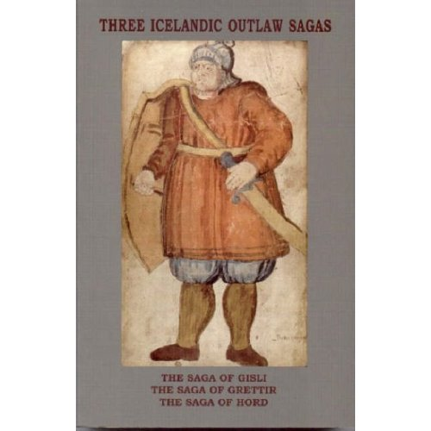
Translated by G. Johnston and A. Faulkes.
Edited and Introduced by A. Faulkes.
The translation of The Saga of Gisli in this volume was made by George Johnston and first published in Everyman’s University Library in 1963 with Notes and an Introductory Essay by Peter Foote. It is here reproduced with only minor changes. The Saga of Grettir was published in G. A. Hight’s translation in Everyman’s Library in 1914 and reissued with an Introduction and Notes by Peter Foote in 1965. This new translation, and that of The Saga of Hord, appeared in Everyman Paperbacks in 2001, and all three translations are now reissued by the Viking Society for Northern Research.
The three sagas translated from Old Icelandic in this volume are all about Icelanders in the Middle Ages who lived and died as outlaws in the Icelandic countryside. Like all other sagas of Icelanders, these three are anonymous, but they were certainly written by Icelanders, probably in the west or north-west of Iceland. It is likely that The Saga of Gisli was written in the first half of the thirteenth century, perhaps about 1230, and thus is part of the first flowering of ‘classical’ Icelandic sagas. The Saga of Grettir is quite a lot later, from the fourteenth century, probably from about 1320 and later than most other sagas of Icelanders. Indeed the most recent editor of the saga (Örnólfur Thorsson, 1994) suggests that it may be from as late as the end of the fourteenth century. The Saga of Hord (called Holmveria saga, ‘the Saga of the Holm-dwellers’, in the principal manuscript) is also a late saga, probably from the second half of the fourteenth century. These last two sagas were therefore written quite a long time after the Icelandic Commonwealth was ceded to the Norwegian Crown in 1262-63, possibly even as late as the time of the union of the Norwegian, Swedish and Danish crowns (1397); and also after translated Romances and Heroic Sagas (fornaldar sögur, Sagas of Ancient Time or Legendary Sagas) may be regarded as having to a large extent superseded Sagas of Icelanders as the primary expression of Icelandic identity and values.
The attitudes to outlawry in Iceland in these texts are interesting to compare with those in English outlaw traditions; the earliest surviving legends of Robin Hood are from the fifteenth century.
2004 / xxviii + 388 pages, paperback / ISBN 0-903521-66-0

