Ágrip af Nóregskonungas†gum

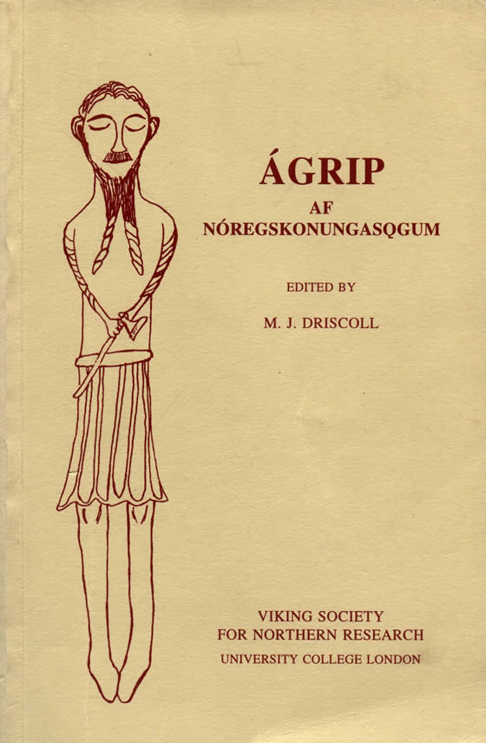

Edited and translated by Matthew Driscoll
Viking Society Text Series Volume X
second edition
Ágrip is a short ‘synoptic history’, written probably in Norway about 1190, summarising the history of Norway from about 880 to 1136. As an important source for later texts such as Fagrskinna and Snorri Sturluson’s Heimskringla, it may be said to have launched the writing of vernacular history in Scandinavia. In Matthew Driscoll’s edition, first published in 1995, the Old Norse text is presented with a facing English translation, full introduction, textual notes and commentary. In this revised edition some errors are corrected and readings revised. 2008. xxv + 126 pp.
ISBN 978 0 903521 75 8.
Price: £6 for members of the Society, £12 for others.

